CHAPTER
15

FILM FORMATION

15.1 INTRODUCTION
With the increasing importance of thin film work, the need has arisen for information on the properties of films and this has necessitated the development of methods of investigation suitable for dealing with thin layers. Many early methods of measuring film thickness required knowledge of the refractive index of the film and vice versa. Procedures now developed which enable both quantities to be determined independently have shown how great is the need for methods which are independent of the assumption that any of the properties of a film (save perhaps, its chemical composition) are the same as those of the material in bulk. By far the most widely used method of depositing films, particularly for use in optical systems, is that of thermal evaporation. Since this method has been most extensively developed. It possesses many advantages over the other methods so films of high purity are readily produced and with a minimum of interfering conditions.
In spite of this favorable aspect, the evaporation method is not universally applicable in practice since, for high melting-point materials, it may well be impossible to deposit films without undue heating of the receiving substrate. The temperature of the substrate during the deposition plays an important role in determining film structure so that any method in which this factor cannot be accurely controlled is to be avoided if reproducible results are to be obtained. For metals for which the evaporation method is unsuitable, the method of sputtering is often used. Sputtering is another vacuum coating process that is used extensively for depositing organic thin films. This process is most easily characterized as a momentum transfer process in which argon or other ions and atoms from a plasma bombard a target made of the material to be coated.
15.2 THE USES OF THIN FILMS
The small vacuum evaporation plant is an almost essential part of the furniture of the research laboratory. In laboratory, thin films find application in a wide variety of type of work. Electrical experiments may often be facilitated by the use evaporated electrodes, which make good contact with the surface without causing mechanical damage. The hygroscopic optical components may be protected by coating with a suitable insoluble film. The difficulties of measuring surface temperatures arc largely overcome by the use of evaporated films as thermocouples.
15.3 SUBSTRATES AND MATERIALS
The type of substrate upon which a filter is deposited generally determines many of the characteristics of the filter, such as durability, stability and cost. There are three major categories of substrates.
- Glasses And Similar Crystalline Materials
- Organics And Plastics
- Metals
Substrates can also be classified as either rigid or flexible. The majority of high-quality optics are fabricated of rigid materials. A large volume of web-coated substrate is produced each year for decorative and other uses. The primary driving factor in the selection of a specific material for a thin film coating is the wavelength region over which it must function. Substrate should be strong enough to survive the handling that they will undergo during the coating process.
Coatings can be deposited on substrates that are at ambient or cooler temperatures. A number of factors related to the substrate limit the upper temperature that can be used;
- Glass transition temperature
- Recrystalline temperature
- Melting temperature
Most optical coatings in the past have been applied to rigid substrate, and these have usually been of a glassy nature. The substrate materials can be metal foils, such as aluminum and stainless steel or organic polymers such as polyethylene terephthalate (PET) and fluorinated hydrocarbons.
15.4 OTHER FILM FORMATION TECHNIQUES
Certainly one of the most technologically important aspects of sol-gel processing is that, prior to gelation, the fluid sol or solution is ideal for preparing thin films by such common processes as dipping, spinning, or spraying.
Compared to conventional thin film formation requires considerably less equipment and is potentially less expensive, however the most important advantage of sol-gel processing over conventional coating methods is the ability to control precisely the macrostructure of the deposited film, i. e., the pore volume, pore size and surface area.
15.4.1 DIP COATING
This process into five stages; immersion, start-up, deposition, drainage, and evaporation. With volatile solvents, such as alcohol, evaporation normally accompanies the start-up, deposition, and drainage steps. The thickness of the deposited film is related to the position of the streamline dividing the upward and downward moving layers. Film thickness depends on six forces;
a) Viscous Drag Upward On The Liquid By The Moving Substrate.
B) Force Of Gravity
C) Force Of Surface Tension
D) Intemial Force Of The Boundary Layer
E) Surface Tension Gradient
F) Pressure
$$h=c_{1}({ηU}/{ρg})^{1/2}$$
h=deposited film thickness
η=liquid viscosity
U=substrate speed
c₁=is constant
ρg=gravity force

Dip Coating

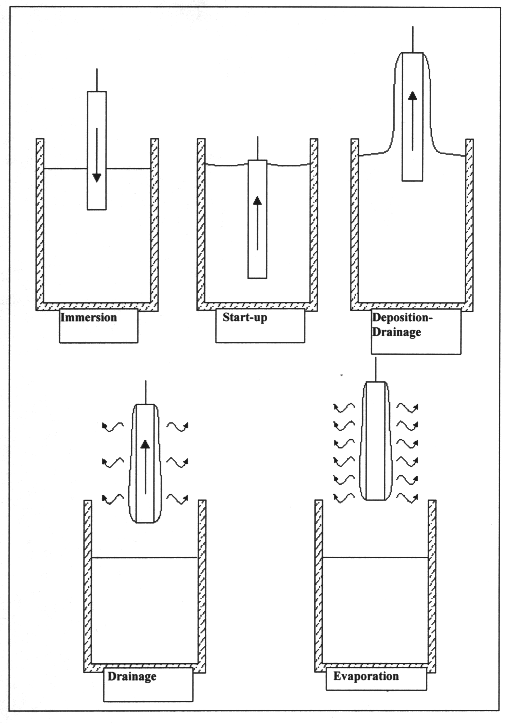

15.4.2 SPIN COATING
Spin coating process is also divided into four stages; deposition, spin-up, spin-off and evaporation. An excess of liquid is dispensed on the surface during the deposition stage. In the spin-up stage, the liquid flows radially outward, driven by centrrifugal force. In the spin-offstage, excess liquid flows to the perimeter and leaves as droplets. As the film thins, the rate of removal of excess liquid by spin-off slows down, because the thinner the film, the greater the resistance to flow and because the concentration of the non-volatile components increases raising the viscosity. In the last stage, evaporation takes place over as the primary mechanism of thinning.
An advantage of spin-coating is that a film of liquid tends to become uniform in thickness during spin-off. The balance between two main forces is important;
Centrifugal force, which drives flow radially outward, and viscosity force which acts radially in ward.
$$h(t)={h_{0}}/(1+4{\text{ρω}}^{2}h_{0^{2}}t/3η)^{1/2}$$
h=initial thickness
ω=angular velocity
t=time

Spin Coating
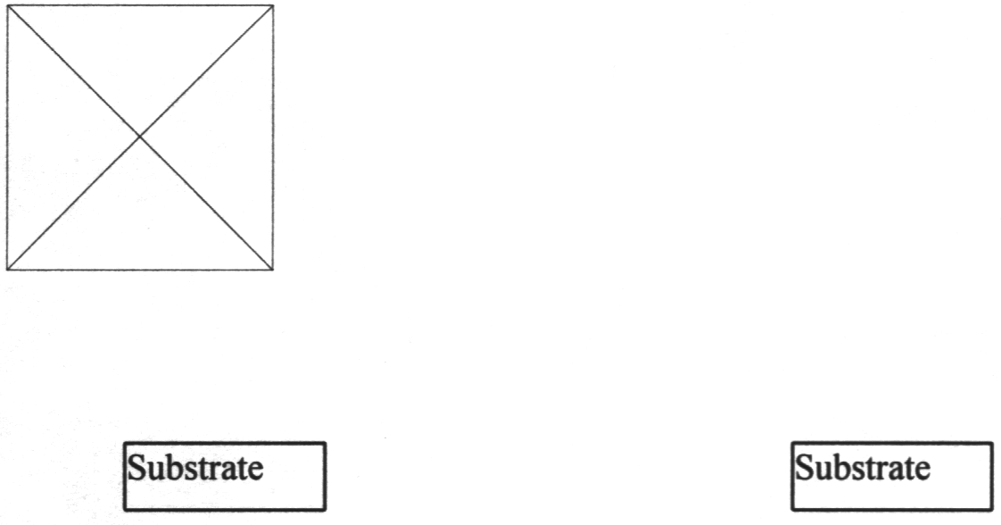
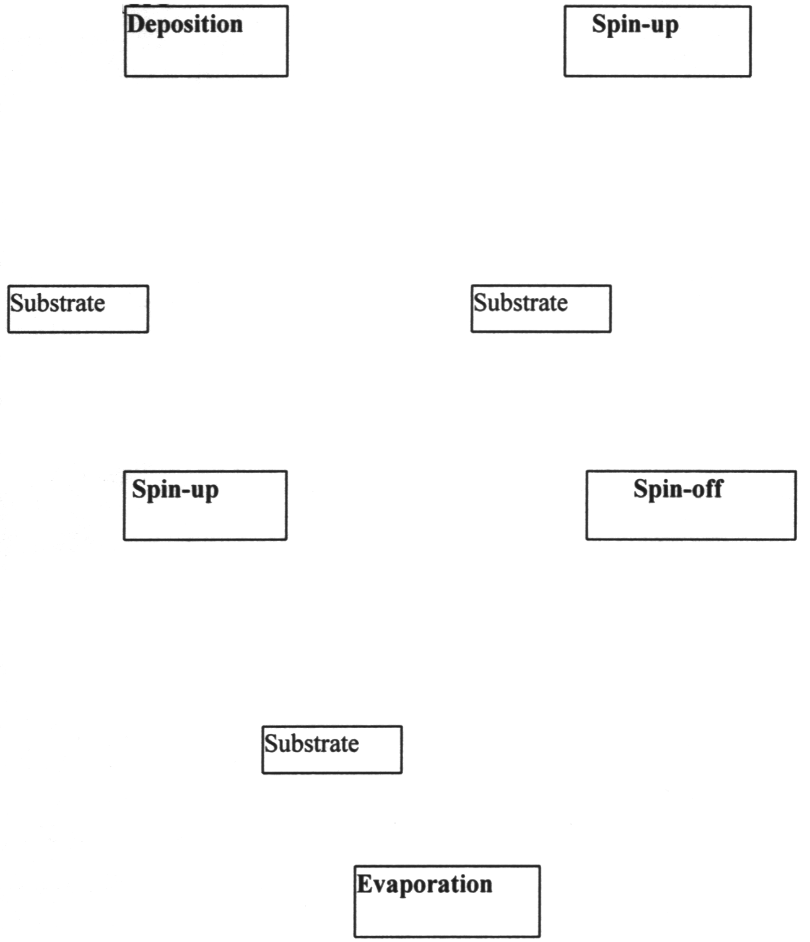
15.5 EXPERIMENTAL
The samples are prepared by spin coating (at 300 rpm and 400 rpm, respectively) a solution of the selected polymer sample in chlorobenzene or chloroform onto a glass substrate (30 mm x 25 x 1) coated with 2 parallel 6 mm wide stripes of Indium-Tin Oxide (ITO) layers, acting as transparent bottom electrodes. This film can be used for electro optic measurements. After drying the films at room temperature for 2 h, then UV-Vis-spcctrum can be recorded.
15.5.1 MATERIALS REQUIRED
SCS Portable precision spin coater Selected polymer sample ITO glass substrate Solvent (chlorobenzene, chloroform)
Beaker
Magnetic stirrer
Filter
Syringe

REFERENCES
- Sol-gel Science, The Physics and Chemistry of Sol-Gel Processing, C. J. Brinker, G. W. Scherer., Academic Press, 1990.
- Optical Thin Films, J. D., Rancourt, SPIE, Optical Engineering Press Washington 1996.
- Optical Properties of Thin Solid Films, O. S. Heavens, Dover Publications Inc., New York 1991.
- Organic Coatings Science and Technology, Z. W. Wicks, F. N. Jones, S. P. Pappas, SPE John, 1999.

